**Ethnography :**

Ethnography is a research method used in social science disciplines. It involves studying people and their cultures through direct observation, participation, and conversation with them.

1. Spend time with people, observe
2. Understand their belief, social practices, ethics, and cultural aspect

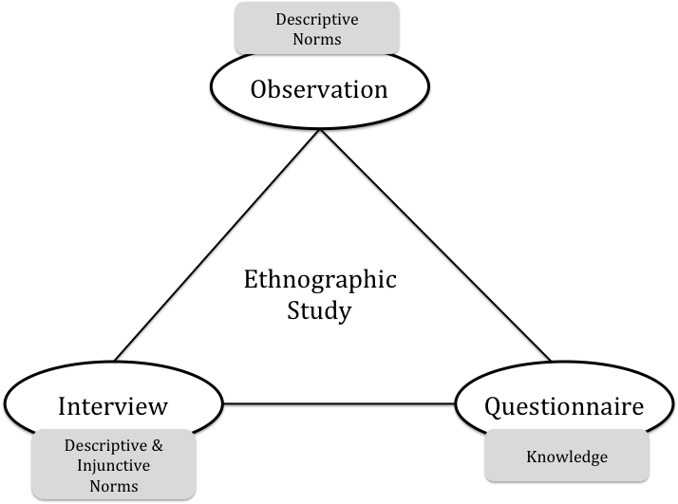

1. Participant observation: This method involves the researcher immersing themselves in the culture or community they are studying. They observe the behavior, rituals, and practices of the group and take notes on their observations.
2. Interviews: Ethnographers conduct interviews with members of the community or group they are studying. These interviews can be formal or informal and may be conducted individually or in groups.
3. Focus groups: Focus groups involve bringing together a small group of people from the community or group being studied to discuss a particular topic or issue. The researcher then observes the group's interaction and takes notes.
4. Surveys: Surveys involve collecting quantitative data from members of the community or group being studied. The data can be used to identify trends and patterns in behavior and attitudes.
5. Archival research: Archival research involves studying historical records, documents, and artifacts related to the community or group being studied. This can provide valuable insight into the group's history and cultural practices.
6. Visual ethnography: Visual ethnography involves using visual media, such as photography or film, to document the community or group being studied. This method can provide a rich and detailed account of the culture and practices of the group.

**Adi Ganga:**

History:

Distributary of Hoogly

Important since the colonial era→ Religious stream and transportation

**Tolly’s Nulah**→ 10 km canal,connects adi ganga with tallygunge → assemblage of people from many countries

Used for trade and drainage and sewage

Post-colonial→dated hydraulic mechanisms,untreated garbage

Since the 1980’s, there was a rise in environmentalism surrounding the river between two sections- the ones who considered encroachers as the culprits and the others who believed that the encroachers had equal agency in river rejuvenation.

Rebati Ranjan Bhattacharya  
  
Metro railway construction (RailWay act)(53% of eastern wetlands, 86% of Tolly’s Nulah)

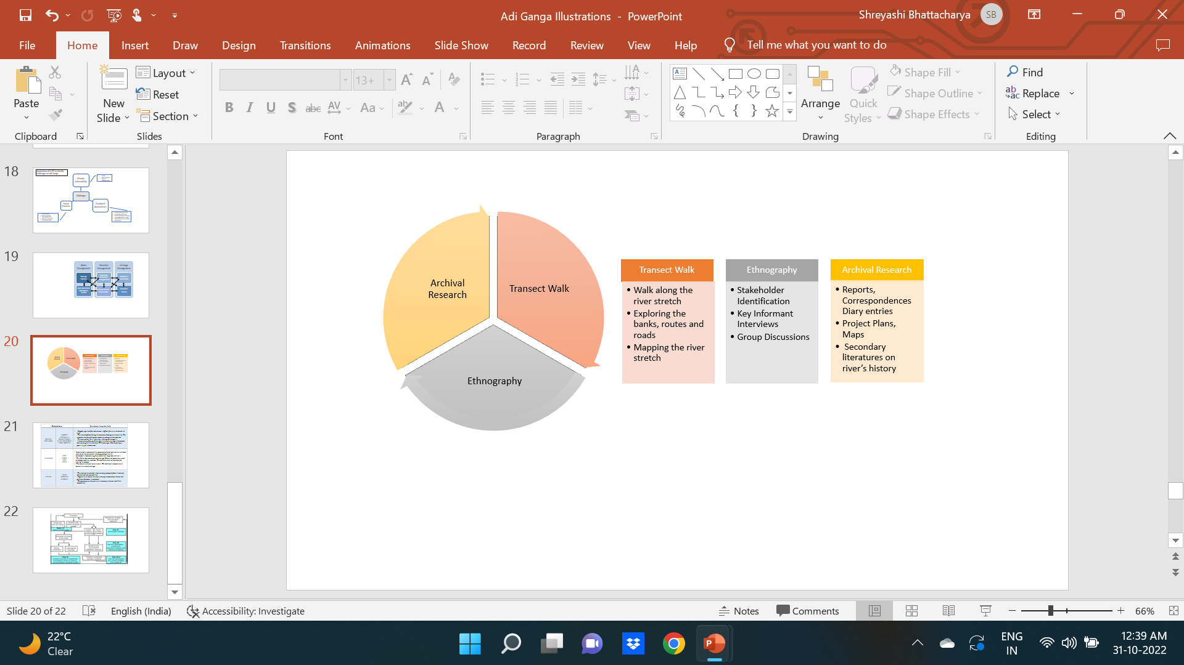

Shoreline participants:-

The river in question holds cultural and historical significance, but also poses health risks to local slum dwellers during monsoon season. Efforts should be made to find a balance between preserving cultural heritage and addressing environmental concerns, prioritizing the health and safety of the local community.

Government:-

One person emphasizes the need to educate locals about the importance of the river and the harmful effects of throwing garbage in it, rather than relying on fines. Another person recognizes the need for improved tools or new plans to treat sewage in light of population growth and increased sewage load.

Activists:- can be revived ,regular cleanup , transparency in policy

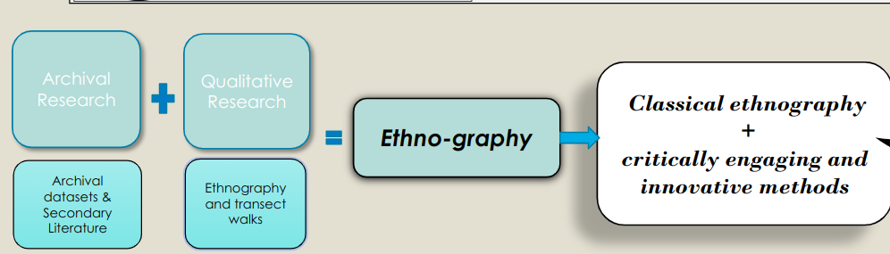

Own perception:- Life-giving,Spiritual,Cultural,Environmental,Economic,Recrational